Board Game Playing Agent
Team Members:
2520030442 – Alleti Sai Pranathi
2520030411 – Manaswi Chilukuri
2520030434 – Kanakala Bindusree

Abstract
Board games such as Chess, Checkers, and Tic-Tac-Toe have long served as benchmarks for Artificial Intelligence research. This project presents a Board Game Playing Agent developed using Python and AI techniques to play strategic board games autonomously. The agent applies search algorithms, game tree exploration, and heuristic evaluation functions to make optimal decisions at each turn.
The agent is built using the Minimax algorithm with Alpha-Beta Pruning to efficiently navigate game trees and select winning moves. It incorporates a PEAS framework, heuristic reasoning, and adversarial search concepts to simulate intelligent gameplay. The system supports human-vs-agent and agent-vs-agent modes, offering an interactive and educational platform to explore foundational AI problem-solving strategies.
Problem Statement
Design and develop an intelligent Board Game Playing Agent that can play a two-player board game against a human or another computer player. The agent should analyze the current game state, evaluate possible moves, and select the best move to maximize its chances of winning.
The system should use Artificial Intelligence techniques such as:
- State Space Search
- Minimax Algorithm
- Alpha-Beta Pruning
- Heuristic Evaluation Functions
The agent must:
- Understand the rules of the game.
- Generate all valid moves.
- Predict future game states.
- Choose the optimal move.
- Compete effectively against an opponent.
Objective
To create an AI agent capable of making intelligent decisions and playing the board game efficiently while attempting to win or achieve the highest possible score.
Example Games
Tic-Tac-Toe, Checkers, Connect Four, Chess (simplified version).
Plan Of Action
Phase 1: Requirement Analysis
- Study existing board game playing AI systems
- Identify target board games:
  - Tic-Tac-Toe
  - Chess
  - Checkers
- Define agent objectives, game rules, and win conditions
Phase 2: Game Environment Setup
- Implement game board representation
- Define game states and transitions
- Encode game outcomes as:
  - Win
  - Lose / Draw

Phase 3: Search Algorithm Development
- Implement Minimax algorithm
- Add Alpha-Beta Pruning for efficiency
- Design heuristic evaluation function
- Set search depth and move generation
Phase 4: Agent Decision Module
Develop decision modules for:
- Evaluating board positions
- Selecting the best move
- Detecting terminal game states
- Adjusting difficulty level

Phase 5: User Interface Development
- Create menu-driven interactive game system
- Add gameplay options:
  - Human vs Agent
  - Agent vs Agent
  - Exit game
Phase 6: AI Concepts Integration
Integrate core AI syllabus topics:
- PEAS agent model
- Adversarial search (Minimax)
- Heuristic evaluation functions
- Decision-making under uncertainty
- Game tree and search strategies
- Alpha-Beta Pruning optimization

Phase 7: Testing & Validation
- Test agent against human players
- Validate agent move quality
- Analyze win/loss/draw statistics
- Improve heuristic and pruning accuracy
Phase 8: Documentation & Presentation
- Prepare abstract and project summary
- Create detailed project report
- Design PPT slides for Board Game Playing Agent
- Demonstrate working Board Game Playing Agent
PEAS Model
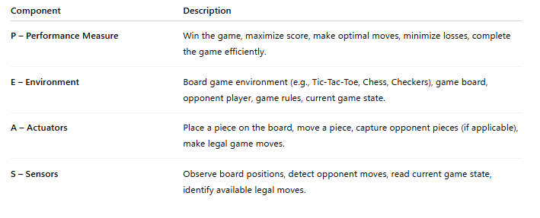
Algorithm
• Start the game.
• Initialize the game board.
• Check whether the game is over.
• Generate all possible legal moves for the current player.
• For each possible move:
- Apply the move to create a new game state.
- Evaluate the game state using the Minimax algorithm.
• Select the move with the best evaluation score.
• Execute the selected move.
• Update the board state.
• Switch to the opponent's turn.
• Repeat steps 3–9 until the game ends.
• Display the result (Win, Lose, or Draw).
• Stop.
CO’S Attainments
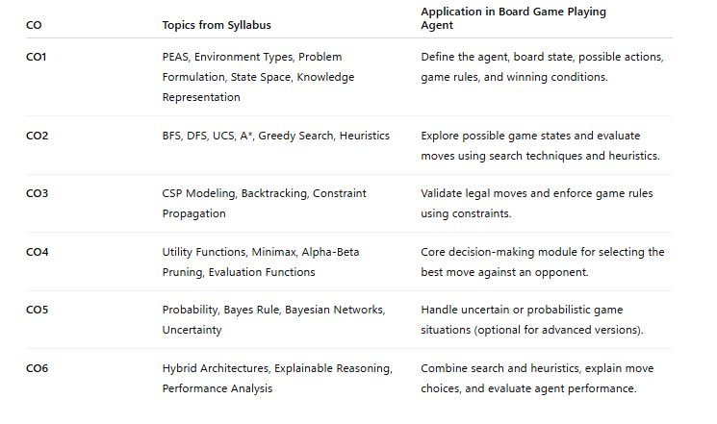
CODE
import math
import copy

# ============================================================
# PEAS MODEL (for Board Game Agent)
# ------------------------------------------------------------
# Performance: Win the game, avoid loss, minimize moves
# Environment: 3x3 Tic-Tac-Toe board
# Actuators: Place X or O on board
# Sensors: Current board state
# ============================================================

PLAYER_X = "X"
PLAYER_O = "O"
EMPTY = " "

# ============================================================
# STATE REPRESENTATION (3x3 grid)
# ============================================================

class TicTacToe:
def __init__(self):
self.board = [[EMPTY for _ in range(3)] for _ in range(3)]

def actions(self):
return [(r, c)
for r in range(3)
for c in range(3)
if self.board[r][c] == EMPTY]

def result(self, action, player):
new_state = copy.deepcopy(self)
r, c = action
new_state.board[r][c] = player
return new_state

def is_winner(self, player):
b = self.board

# rows, cols, diagonals
for i in range(3):
if all(b[i][j] == player for j in range(3)):
return True
if all(b[j][i] == player for j in range(3)):
return True

if all(b[i][i] == player for i in range(3)):
return True
if all(b[i][2 - i] == player for i in range(3)):
return True

return False

def terminal(self):
return self.is_winner(PLAYER_X) or self.is_winner(PLAYER_O) or len(self.actions()) == 0

def print_board(self):
for row in self.board:
print(row)
print()

# ============================================================
# HEURISTIC EVALUATION FUNCTION
# (used in Minimax depth limiting / greedy strategy)
# ============================================================

def heuristic(state):
if state.is_winner(PLAYER_X):
return 10
if state.is_winner(PLAYER_O):
return -10

# small heuristic: center control + corners
score = 0
center = state.board[1][1]

if center == PLAYER_X:
score += 1
elif center == PLAYER_O:
score -= 1

return score

# ============================================================
# MINIMAX WITH ALPHA-BETA PRUNING
# ============================================================

def minimax(state, depth, alpha, beta, maximizing):
if state.terminal() or depth == 0:
return heuristic(state)

if maximizing:
max_eval = -math.inf
for action in state.actions():
child = state.result(action, PLAYER_X)
eval = minimax(child, depth - 1, alpha, beta, False)
max_eval = max(max_eval, eval)
alpha = max(alpha, eval)
if beta <= alpha:
break # alpha-beta pruning
return max_eval

else:
min_eval = math.inf
for action in state.actions():
child = state.result(action, PLAYER_O)
eval = minimax(child, depth - 1, alpha, beta, True)
min_eval = min(min_eval, eval)
beta = min(beta, eval)
if beta <= alpha:
break
return min_eval

# ============================================================
# BEST MOVE SELECTION (AI AGENT DECISION FUNCTION)
# ============================================================

def best_move(state, player):
best_score = -math.inf if player == PLAYER_X else math.inf
best_action = None

for action in state.actions():
new_state = state.result(action, player)
score = minimax(new_state, 3, -math.inf, math.inf, player == PLAYER_O)

if player == PLAYER_X and score > best_score:
best_score = score
best_action = action

if player == PLAYER_O and score < best_score:
best_score = score
best_action = action

return best_action

# ============================================================
# BFS EXAMPLE (STATE SPACE EXPLORATION IDEA)
# (Not used for playing, but for learning search concepts)
# ============================================================

from collections import deque

def bfs_win_path(start_state):
queue = deque([(start_state, [])])
visited = set()

while queue:
state, path = queue.popleft()

if state.is_winner(PLAYER_X):
return path

state_key = str(state.board)
if state_key in visited:
continue
visited.add(state_key)

for action in state.actions():
next_state = state.result(action, PLAYER_X)
queue.append((next_state, path + [action]))

return None

# ============================================================
# SIMPLE GAME LOOP (AI vs AI)
# ============================================================

def play_game():
game = TicTacToe()
current_player = PLAYER_X

while not game.terminal():
game.print_board()

if current_player == PLAYER_X:
move = best_move(game, PLAYER_X)
else:
move = best_move(game, PLAYER_O)

print(f"{current_player} plays: {move}")
game = game.result(move, current_player)

current_player = PLAYER_O if current_player == PLAYER_X else PLAYER_X

game.print_board()

if game.is_winner(PLAYER_X):
print("X wins!")
elif game.is_winner(PLAYER_O):
print("O wins!")
else:
print("Draw!")

# ============================================================
# RUN
# ============================================================

if __name__ == "__main__":
play_game()

Outut
